CSCE 5580 – COMPUTER NETWORK SPRING 2023

SET-2

1. a) As we know that internet is a nut and bolt’s view. Can you think of any real-life example that can relate to the Internet? For instance, the Logistic services end system could be sender and receiver, the connection means could be any of the modes of transportation and Storage can be considered as switches and routers.
   1. What is protocol and explain it with a real-time example?
   2. Explain about access network briefly?

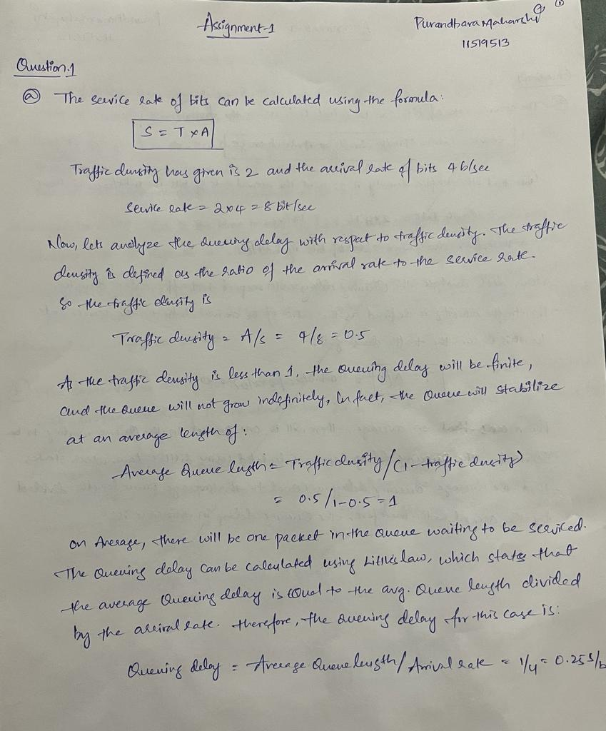

1. Consider the following circuit-switched network where there are 4 links available between each router:

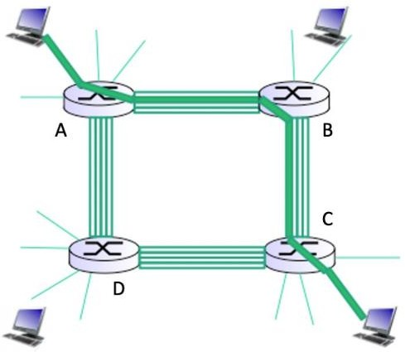

1. Determine the maximum number of simultaneous connections supported at any one time in this network.
2. Suppose that users at the A router want to connect to end users at the C router. Determine the maximum number of simultaneous connections supported at any one time in this network for this scenario.
3. Now, suppose that we have 4 users at the A router wanting to connect to end users at the C router and 4 users at the B router wanting to connect to end users at the D router. Is it possible to simultaneously make these 8 connections in this network? Justify your answer.

1. Suppose that you have 150 terabytes (note that bytes, not bits, are used here) of data on a drive that you need to be delivered within 24 hours, but preferably faster. If your company has a dedicated 9 Gbps link available to transfer this data, would it be better to use FedEx overnight delivery (will be delivered in exactly 24 hours, but no earlier) or transmit the data on your dedicated link if these are your only options? Show calculations to justify your answer.

1. Consider a packet-switching architecture:
2. List and briefly describe the four main components of delay.

1. Concisely describe what the difference is between transmission and propagation delay.

1. How would the propagation delay be affected if the length of the packet is increased?

Top of Form

1. a) As we know that internet is a nut and bolt’s view. Can you think of any real-life example that can relate to the Internet? For instance, the Logistic services end system could be sender and receiver, the connection means could be any of the modes of transportation and Storage can be considered as switches and routers.

* 1. What is protocol and explain it with a real-time example?

* 1. Explain about access network briefly?

